**R Code for Examples in the book**

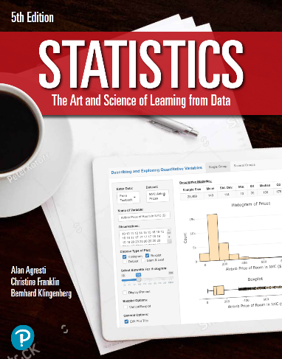

***“Statistics: The Art and Science of Learning from Data”***

**by Agresti, Franklin and Klingenberg, 5th edition**

**Chapter 4**

**Example 5: Auditing a School District – Selecting a Simple Random Sample**

## To draw a sample of size 10 accounts from 67 accounts (without replacement)

sample(67, 10)

## [1] 49 43 67 3 42 12 48 32 59 38

## Note that replace = FALSE is a default argument in the sample() function. To draw with replacement, you can set replace = TRUE

sample(67, 10, replace = TRUE)

## [1] 17 9 19 26 39 16 36 3 36 48